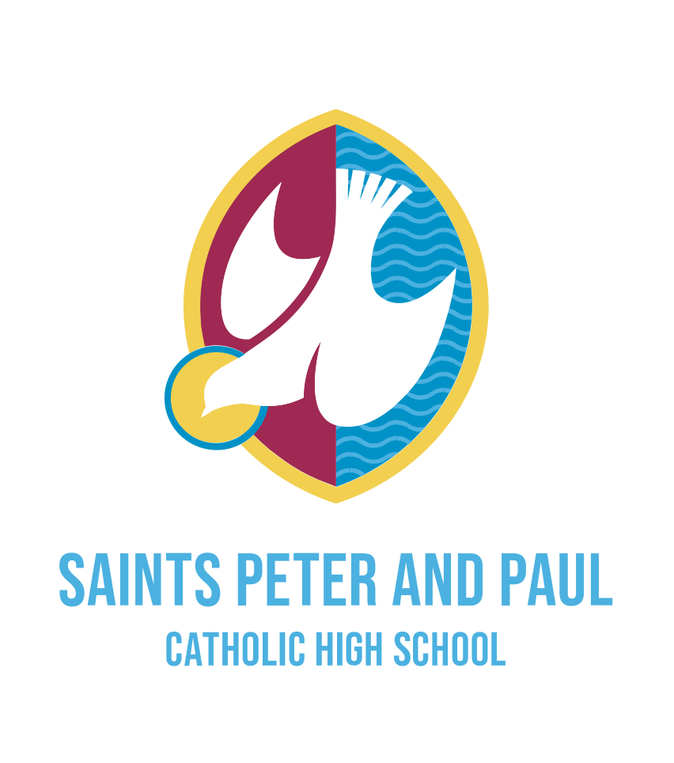
Job Advert

Specialist Teaching Assistant/Cover Supervisor
(Supporting our Alternative Provision Students)

HBC 4 £17,056-£18,462 (pay award pending)
Term Time Only: 37 hours per week

The future looks bright for the students and staff at Saints Peter and Paul. As well as investing almost £1m in the premises, governors have also supported the expansion of our associate staff structure to enhance the services on offer to our community. With healthy pupil numbers and a thriving reputation, the school is going from strength to strength, as we fulfil our mission to be “An Inclusive Community of Excellence and Opportunity”

At our vibrant and dynamic school, we focus on being respectful, aspirational and compassionate. Every member of staff plays an important role in promoting these values and the school is proud of its open, collaborative, supportive and forward-thinking culture.

The Inclusion Team is made up of experienced and professional staff who recognise that students need a full range of support to maximise their potential at high school. Our Teaching Assistants are skilled in meeting the needs to students in full class settings, on a one to one basis and through small group activities. Ambitious candidates can expect opportunities to professionally develop and progress within the Inclusion Team.

We require a Teaching Assistants/Cover Supervisor, who will focus on supporting students accessing a bespoke curriculum. We are seeking candidates who are relentlessly positive and will relish the opportunity to join our dedicated and talented staff in September 2022.

We will offer you the opportunity to;

- Be welcomed into our supportive staff team and experience our special sense of community
- Be supported in your continued professional development
- Become part of the extremely strong and supportive Archdiocese of Liverpool Secondary School Improvement Trust in which there are regular opportunities to collaborate and share practice

Prospective applicants are most welcome to arrange to visit by emailing Mr Stuart Evans, Director of Finance and Resources on evanss@saintspeterandpaul.halton.sch.uk

Further information and an application form can be found on the school website: Saints Peter and Paul Catholic High School | Vacancies

Please send completed CES application forms to evanss@saintspeterandpaul.halton.sch.uk

Strictly no CVs. CES Application forms only with supporting statement.

Closing date for applications is 9am on Monday 22nd August 2022
Interviews scheduled for Thursday 25th August 2022.

Saints Peter and Paul Catholic High School is committed to safeguarding and promoting the welfare of students and the post is subject to an enhanced DBS check and references.

